

JK LAKSHMIPAT UNIVERSITY

DIGITAL CIRCUIT AND SYSTEMS  
(EE1120)

Activity 03

Conversion from NAND gate

To all basic gates

Date : 25th January 2023

Name : Bobby Sharma

AIM: Design all the logic gates using NAND gate only on breadboard.

APPARATUS REQUIRED:

* Breadboard
* Jumping wires
* Connecting wires
* LED
* Resistor
* NAND (IC = 7400)
* Battery

THEORY: A logic gate is a simple switching circuit that determines whether an input pulse can pass through to the output in digital circuits. The following types of logic gates are commonly used:

* AND
* OR
* NOT
* NOR (Universal gate*)
* NAND (Universal gate*)
* XOR
* XNOR

(* A universal gate is a logic gate which can implement any Boolean function without the need to use any other type of logic gate.)

* NOT GATE: The IC number of the NOT gate is 7404 Hex Inverter. The output given by this gate is inversion to the input as shown in figure 1. The conversion from NAND gate to NOT gate can be done by using the same input which results in the conversion of the input given by the user.

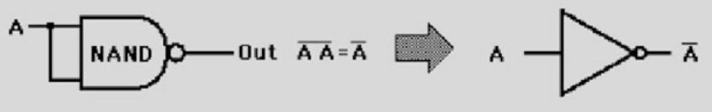

Figure 1

* AND GATE: The IC number of the AND gate is 7408. This gate gives the output by multiplying both the inputs. The Quad AND gate are shown in figure 2. The conversion can be done by just reversing the output of the NAND gate which will lead us to expected output of AND gate.

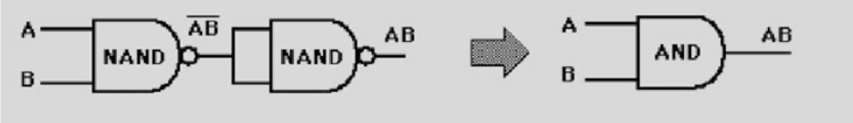

Figure 2

* OR GATE: The IC number of the OR gate is 7432. This gate gives the output by addition of both the inputs. The Quad OR gate are shown in figure3. The conversion is done by applying De-Morgan’s Law on A+B which is explained in figure 3. The output can check through the truth table of OR gate.

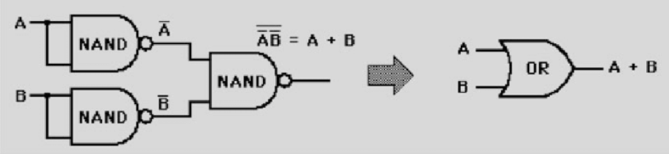

Figure 3

* X-OR GATE: The IC number of the X-OR gate is 7486. The Quad OR gate are shown in figure 4 and 5. As we know the other way of representing X-OR gate is as follows Y = A.(Complement of B)+ (Complement of A).B

As the representation suggests, we must make the AND gate from A and Complement of B and vice versa. Later, we must take their output as an input and make the OR gate which will give us the output of X-OR gate.

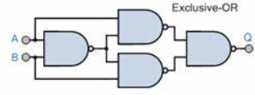

Figure 4

* X-NOR GATE: The representation is Y = Complement of (X-OR GATE). The X-NOR gate is shown in figure 6 and 7. It is combination of X-OR gate with the NOT gate. So, we can just add the combination of NAND gate (that we used for NOT gate) to the combination of NAND gate (that we used for X-OR gate).

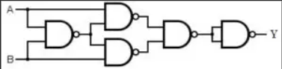

Figure 6

OBSERVATION: The observed outputs of all the basic gates are as follows:

* X-OR GATE:

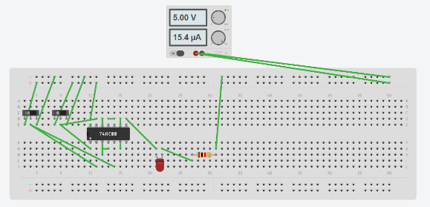 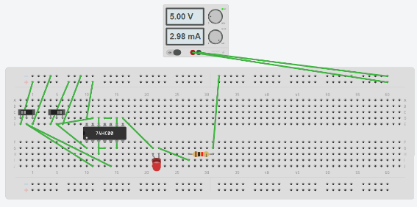

Figure 18 Figure 19

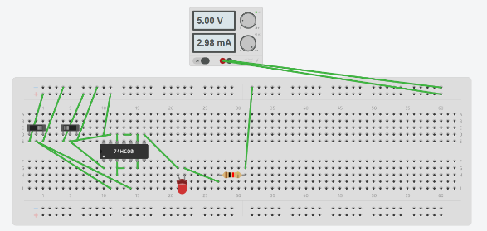 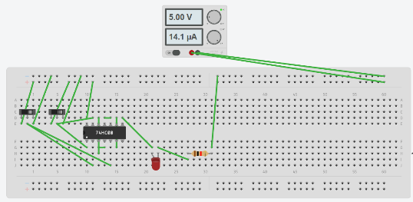

Figure 20 Figure 21

Figure 22

Figures 18,19,20 and 21 are showing the outputs when both the slider switch is on and off. By observing this we can make the truth table of OR gate which is shown in table 4.

|  |  |  |
| --- | --- | --- |
| A | B | Y = A+B (Exclusive or) |
| 0 | 0 | 0 |
| 0 | 1 | 1 |
| 1 | 0 | 1 |
| 1 | 1 | 0 |

Table 4

* X-NOR GATE:

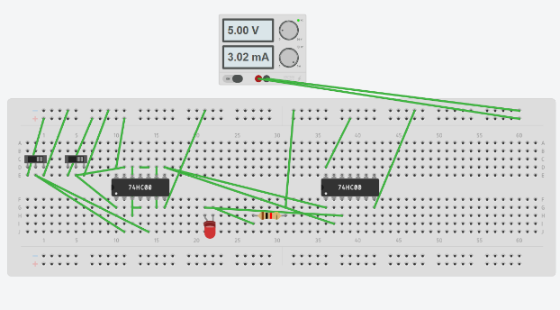 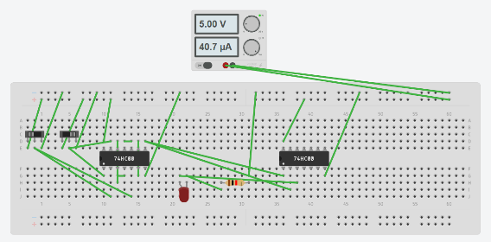

Figure 22 Figure 23

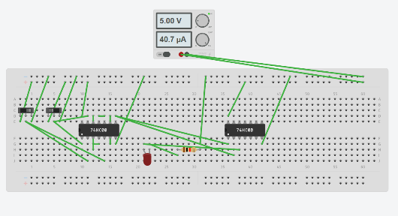 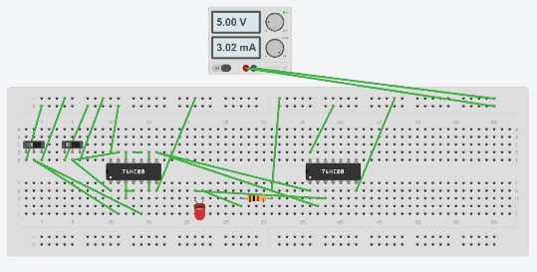

Figure 24 Figure 25

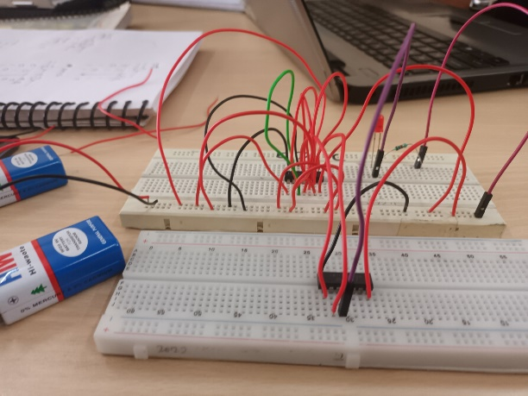

Figure 26

Figures 22,23,24 and 25 are showing the outputs when both the slider switch is on and off. By observing this we can make the truth table of OR gate which is shown in table 5.

|  |  |  |
| --- | --- | --- |
| A | B | Y = Complement of X-OR gate |
| 0 | 0 | 1 |
| 0 | 1 | 0 |
| 1 | 0 | 0 |
| 1 | 1 | 1 |

Table 5

RESULT: We have concluded all the truth tables of all the basic logic gates from NAND gate on breadboard.

APPLICATION IN DAILY LIFE:

Converting NAND gates into other gates in daily life is not a direct practical application that you would encounter in everyday scenarios. However, the significance lies in the theoretical and practical aspects of digital circuit design. Here are some reasons why converting NAND gates into other gates is important in the field of digital electronics:

* Universal Property: NAND gates are considered universal gates because you can use them to create any other basic logic gate. This universality simplifies circuit design and reduces the number of gate types needed in integrated circuits.
* Simplification of Circuit Design: Converting NAND gates into other gates allows designers to simplify circuit designs. By using a single type of gate (NAND), it becomes easier to standardize and optimize the layout of digital circuits.
* Economic Considerations: Integrated circuit manufacturing involves the fabrication of millions or even billions of transistors on a single chip. If a NAND gate can be used to implement various other gates, it can lead to cost savings in terms of manufacturing, testing, and overall production.

In summary, while the direct need for converting NAND gates into other gates may not be evident in everyday life, it is a fundamental concept in digital electronics and circuit design. Engineers and designers leverage this knowledge to create efficient, standardized, and cost-effective digital systems.